Luke 15:1-10

Lost Sheep - Jesus explains what a person means to God  - The Shepherd made a plan  - The Shepherd made some risk  - The Shepherd rejoiced at the rescue of the sheep  - The Shepherd was pleased with the plan and the risk  - Mental Sticky note: Jehovah is concerned with the 1 of 100  Lost Coin  - Oh, I have 10 more - also not the shepherd’s reaction  - Significant loss - The lost are called “The Lost”  - Significant effort (sacrifice)  Milky Way:  - How huge, how small, how massive, how insignificant  - No actual known image  - Adam Shanks  - There are at least 300 billion stars in our Milky Way Galaxy and around 10 trillion planets in our galaxy  - There are over 100 billion galaxies in our universe at our latest count (estimate). Many are larger, many are smaller, but let’s use our estimate.  - Multiply 10 trillion planets by 100 billion galaxies = 1,000,000,000,000,000,000,000,000 (one septillion) planets and God cares about ours!  - He is not confounded by the numbers  - Did it come from nothing?  DNA  - Building blocks of cell replication  - Discovered in 1870’s but Helix pattern and composition ACGT discovered appx 1953  - Fun Facts  - Can anyone say it has no design?  - Who cared about the code? We sure didn’t.  Conclusion  Genetically Modified Sheep Lost in Space losing money.  - God is aware of, loves, and knows me.  - If he controls chaos and gives design to the cosmos, is the salvation of my soul too difficult for him?  - Spacial greatness and smallness is nothing to the creator of time, mass, and space  - God’s love is personal toward me because he cares about me  - He is aware of and understands my needs  - He is aware of His church  Is he aware of this church? Our efforts? Our weaknesses? Our hurt? Our wolves? Our ONE LOST SHEEP?  If he can reach down from his side of eternity to know, love and care out this currently small group, should we not,as we reach out to the lost, also lean inward for encouragement, comfort and strength to and from one another?  Are we merely OK with the 99 - complacency  His creation is great. His design is awesome. Let us also be engaged with His church which was purchased with the blood of his son. | 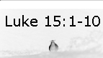  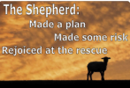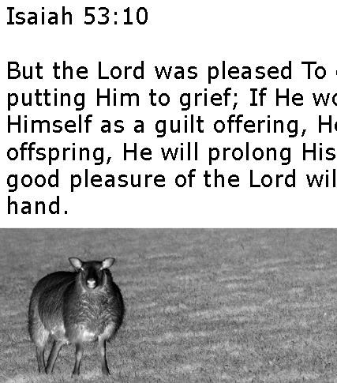  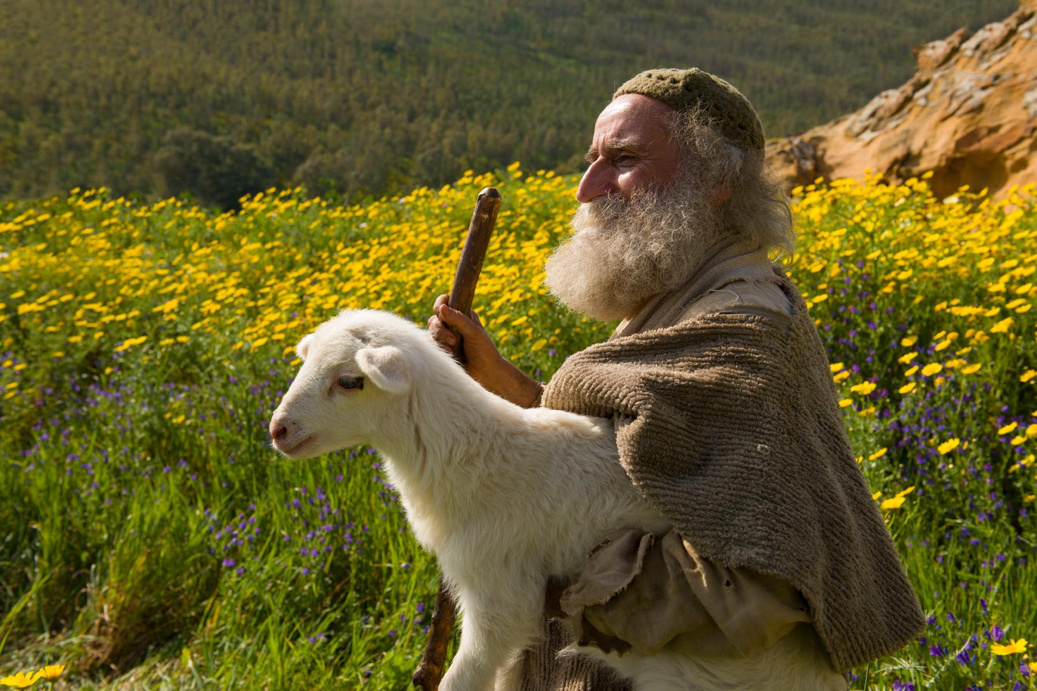  Woman  Woman  Coin  Significant loss  Significant effort  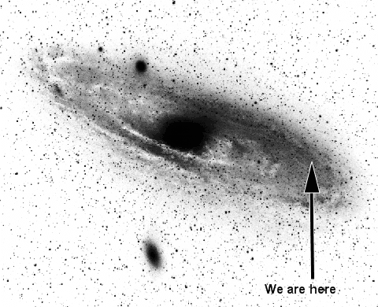  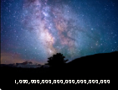  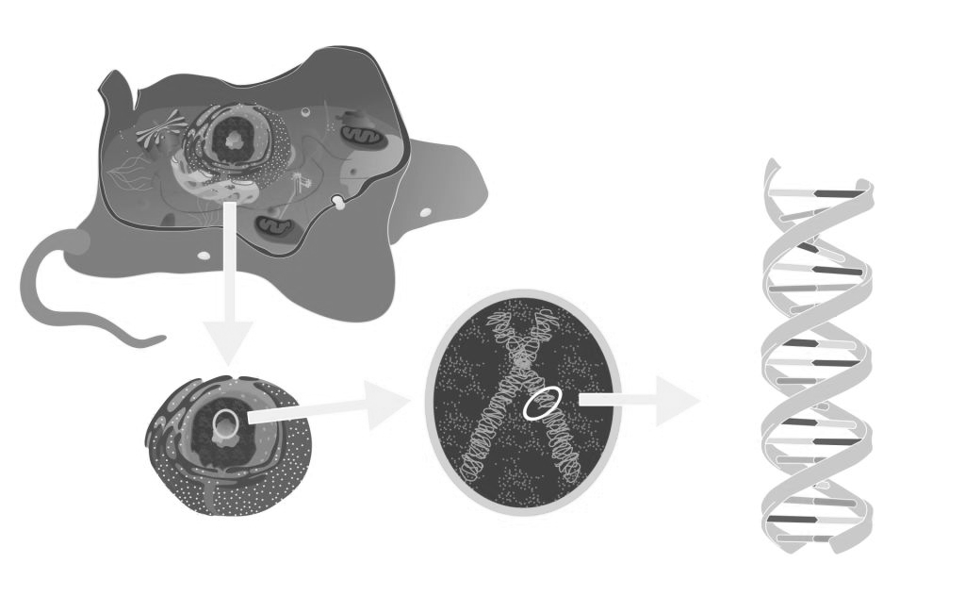  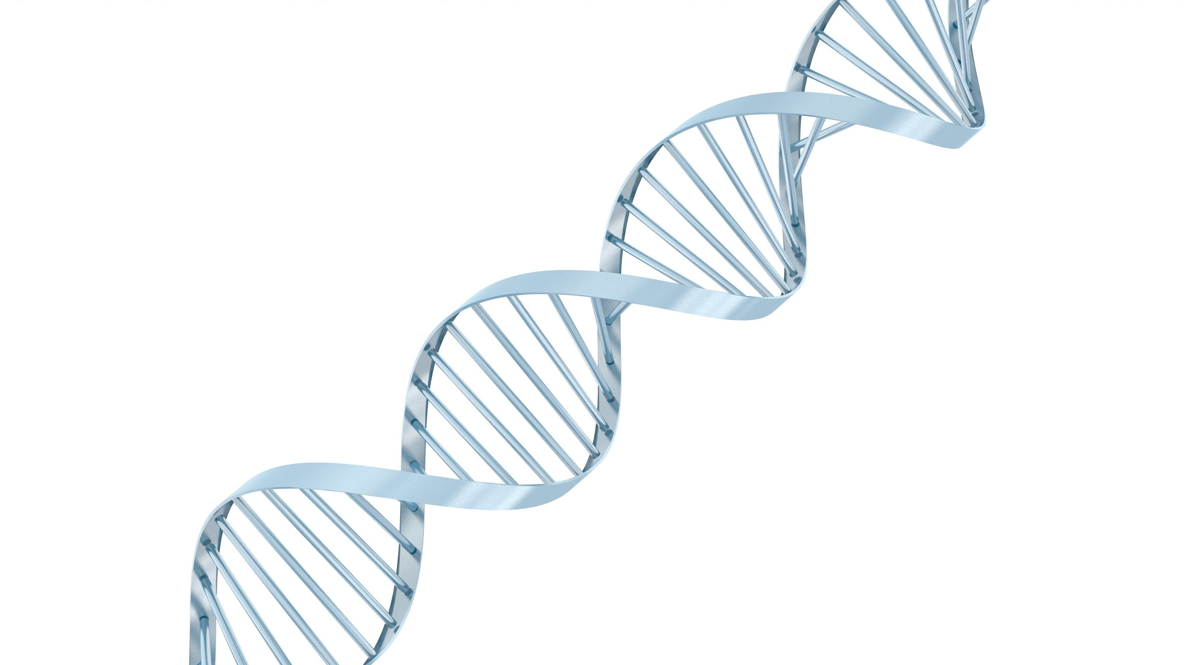  Space sheep  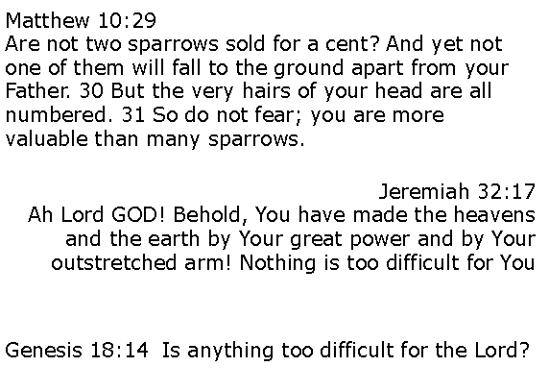  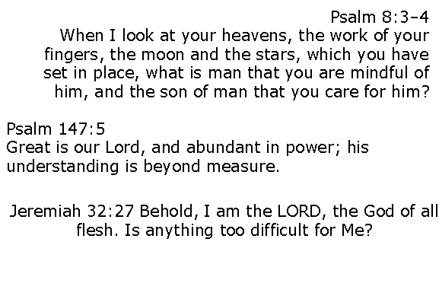  Revelation Chapter 2 and 3  “I know your deeds”  1 Thessalonians 5:9-11  For God has not destined us for wrath, but for obtaining salvation through our Lord Jesus Christ, who died for us, so that whether we are awake or asleep, we will live together with Him. Therefore encourage one another and build up one another, just as you also are doing.

